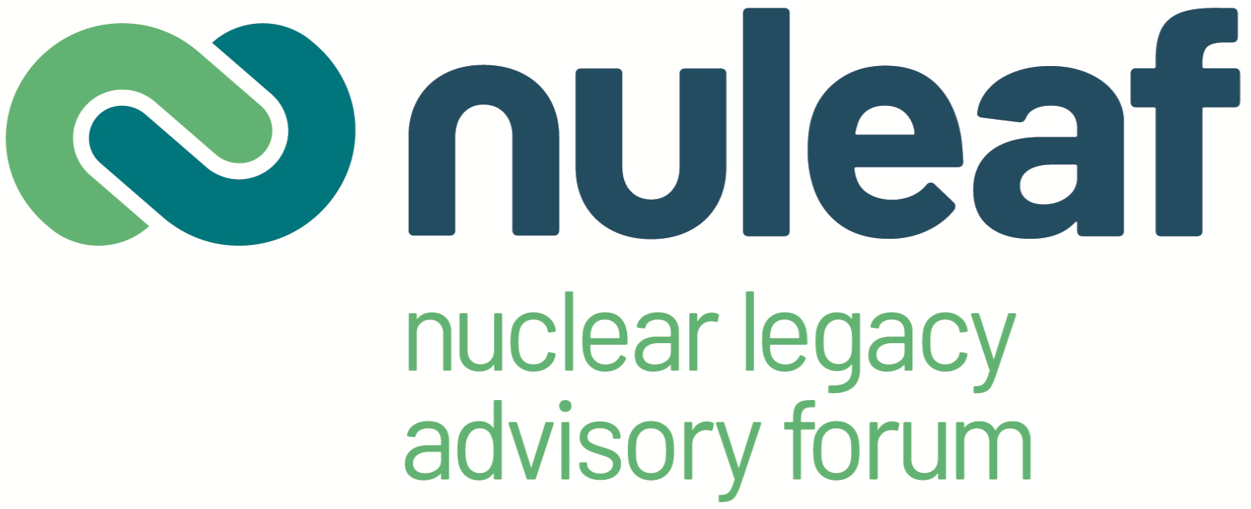

NOTE OF NULEAF WELSH MEMBER AUTHORITIES MEETING, 24th SEPTEMBER 2021

Present:

Group Llandrillo Menai
Dafydd Evans, Chief Executive Officer
Aled Jones Griffith, Principal - Coleg Menai & Coleg Meirion Dwyfor
Paul Bevan, Executive Director - Commercial Development
Damian Woodford, Programme Area Manager – Engineering

Department of Business Energy and Industrial Strategy
Dawn Armstrong, Radioactive Waste Disposal Infrastructure Policy

Gwynedd County Council
Cllr Dyfrig Lewis Siencyn, Leader of the Council
Sioned Williams, Head of Economy & Community
Nia Carys Bowden, High Value Jobs Scheme Manager
Dylan Rhys Griffiths, Economic Development Programmes Manager
Robin Wynne Williams, Senior Minerals and Waste Planning Officer

Magnox Ltd
Gwen Parry Jones, Chief Executive Officer
Bill Hamilton, Communications & Stakeholder Relations Director
Stuart Law, Wylfa Site Director
Angharad Rayner, Trawsfynydd Site Director

Natural Resources Wales
Paul Gibson, Radioactivity & Industry Policy Team Leader

North Wales Growth Deal
Elgan Robert, Energy Project Manager

Nuclear Decommission Authority
David Peattie, Group Chief Executive Officer
John McNamara, Head of Stakeholder Engagement
Neil Smith, Business Manager – Economic Development, NDA
Jonathan Jenkin, Stakeholder Relations and Socio Economics Manager – Magnox
Simon Napper, Stakeholder Relations and Socio Economics Manager Designate – Magnox

Snowdonia National Park Authority
Sion Roberts, Planning (Policy) Officer

Welsh Government
James Gibbs, Radioactivity Policy
Ross Hockley, Senior Environment Protection Policy Manager
Wyn Roberts, Head of Nuclear
Laurence Smith, Senior Nuclear Policy and Delivery Manager

Isle of Anglesey County Council
Cllr Carwyn Jones, Portfolio Holder – Major Projects and Economic Development
Dylan Williams, Deputy Chief Executive
Rhys Jones, Energy Island Programme Delivery Manager

Nuleaf
Philip Matthews, Executive Director
Catherine Draper, Director’s Assistant

1. Welcome and introductions

Phil Matthews welcomed members and speakers to the meeting. He hoped this would be the first of what would become an annual meeting looking at the issues specific to Nuleaf’s Welsh member authorities.

2. Overview of NDA activities, David Peattie, NDA
Mr Peattie gave a presentation highlighting the changes to the organisational structure of the NDA.
- The Parent Body Organisation (PBO) model had ceased and the company now comprised the NDA and a number of subsidiary companies.
- Magnox Ltd may be renamed to better reflect its work, but as yet no decision had been taken.
- NDA accepted that it needed to engage with new nuclear activities as they were part of the government’s route towards net zero carbon.
- Progress on decommissioning was progressing faster than had been hoped.
- A decision was awaited from Treasury on the funding settlement. This would influence the speed with which decommissioning could be carried out.
- Mr Peattie acknowledged that recruitment and retention was a challenge. The NDA graduate programme was very successful, but the profile of the workforce was aging and this needed to be addressed.
- NDA is proud of the work it carries out in the communities around its sites. Hazel Blears had been commissioned to carry out work on social value. She challenged the NDA to use the £3 billion annual spend in the NDA supply chain to better advantage.

3. Presentation on Magnox activities, Gwen Parry Jones, , Magnox Ltd

Ms Parry Jones gave an overview of the company and its activities. Key points were:
- Magnox comprises 12 nuclear licensed sites and the Maentwrog hydro-electric plant.
- Magnox employees 2500 people not including the supply chain.
- It has an annual spend of around £0.5 billion.
- Magnox employees worked to help their communities during the early stages of the Covid-19 pandemic.
- All sites are now defueled and the company now focuses on waste management and demolition.
- The work programme is moving to rolling decommissioning, with Trawsfynydd acting as a lead and learn site. This brings a need for technical innovation and creates opportunities for the supply chain. The level of funding will drive the pace of work.
- Magnox is looking to create sustainable skills to deliver the wider mission.
- With the addition of Dounreay and the transfer of AGR reactors following defueling by EDF the size of the company will double.
- Consideration is being given to renaming to company to more accurately reflect its role and mission.
- The average age of a Magnox employee is 54. Renewal of skills is an important issue and Magnox needs to give local authorities and education establishments forward plans so they area aware of what skills the company will need.
- Magnox has adopted REGENERATION as a key word
- Magnox’s Site Stakeholder Groups are important and they need to work for the local community.
- Magnox increasingly tries to facilitate the engagement of smaller local companies in consortia to bid for work.

In response to a question regarding apprenticeships at Trawsfynydd the meeting was advised that Trawsfynydd took on 5 apprentices last year and a further two this year. Magnox has drawn up a People Plan and are looking at how we can get new people in to work for them.

Mr Peattie commented that social value starts locally and by ring fencing specific funds for specific projects NDA/Magnox can kick start socio-economic projects. NDA, through Magnox, provides long lived work for local businesses and communities. NDA looks to maintain its skilled workforce including using redeployment where possible.

Magnox contractors were well supported through the pandemic which enabled them to keep their staff on the payroll. As a result Magnox was able to restart work. Magnox was grateful for UK government support which enabled them to do this.

4. Developing a decommissioning framework for Wales and UK policy, James Gibbs, Welsh Government and Dawn Armstrong, BEIS.

Dawn Armstrong gave an overview of the work BEIS is doing, in conjunction with the devolved adminstrations to update UK radioactive waste policies.
- They are working together to bring all policies across the UK into a single policy framework. This was necessary as the framework hadn’t been updated since 1995 and there had been subsequent policy changes and additions. A new framework would provide clearer guidance to regulators.
- Consultation on the revised framework is expected later this year.
- In addition, consultation will take place on the disposal of less hazardous Intermediate Level Waste (ILW) to near surface disposal (NSD) rather than to a geological disposal facility (GDF). Adoption of near surface disposal could aid earlier decommissioning.
- The updated policy framework will support the application of the waste hierarchy and give operators a strong message about minimising waste prior to disposal. It will also support on-site disposal of radioactive waste where permissable.
- The consultation documents are awaiting ministerial clearance.

James Gibbs advised that the policy would reflect the importance of the Welsh language and noted that the Welsh government’s policies on the siting process for a geological disposal facility for higher activity waste was separate from England, but was complementary.

5. Socio-economic activities and post-Covid recovery, Wyn Roberts, Welsh Government and Neil Smith, NDA

Mr Roberts thanked Nuleaf for the opportunity to present to this group. Key points from his presentation were:
- Welsh Government are looking to invest in projects across North Wales.
- The Welsh Government recognises the importance of moving to rolling decommissioning with long term opportunities for people to stay in employment at Trawsfynydd.
- Cwni Egino has been established to negotiate a development mandate for the Trawsfynydd site. Potential opportunities include deployment of Small Modular Reactors (SMRs) and construction of an OPAL type reactor to generate medical isotopes. The latter has the potential to be a collaboration between the four UK nations.
- There are 500 hectares of development land at Wylfa, and it has the potential to be one of the best locations in Europe for large scale new nuclear.
- The Welsh Government is also working on a range of regional projects, research and innovation opportunities, and supply chain opportunities for the Hinkley Point C and Sizewell C construction projects.

Mr Smith spoke on NDA’s approach to socio-economic support. Key points were:
- Under the Energy Act 2004, NDA is required to consider decommisisoning in a socially responsible way, looking at what opportunities decommissioning creates and the ways in which benefits can be maximised for local communities. The negative impacts and associated mitigation also need to be considered.
- NDA contributes up to £15 million per annum to supporting local economic, environmental and social regeneration. It needs to ensure that it is delivering what the community wants. It also needs to consider its ‘intentionality’ and look at the business decisions it makes and what positive impact they could have.
- NDA looks to work in partnership with local communities and their representative bodies.
- There has been a 20% decline in applications for funding across the NDA estate and they are keen to understand why this is and what they can do to help support and develop applications.
- NDA will be undertaking a refresh of its economic impact studies.

6. Presentation, Daffyd Evans, Group Llandrillo Menai

Mr Evans gave a presentation on the work of Group Llandrillo Menai and its aspirations for the future.
- Made up of 3 colleges covering 13 campuses it has an annual turnover of £77 million and is one of the top 10 largest educational institutions.
- It aims to provide a suitably qualified and competent workforce for the construction and operation of Wylfa Newydd, and by doing so to improve the lives of the local population and support the local communities, culture and Welsh language.
- The group has worked with partners to deliver its projects and NDA has supported all these.
- With the cessation of Horizon’s proposal to develop new nuclear at Wylfa Newydd, the group has sought new employers to work with, such as Babcock.
- The group is ready to support Magnox and the delivery of its mission. It is also keen to be part of the proposed developments at Trawsfynydd.

Mr Evans thanked Jonathan Jenkin of NDA for the support he had given them in developing their funding applications.

In response to a question regarding the potential for blanket funding to each Magnox site area, Mr Smith said this approach would be difficult in the short term as it differed from their current approach, but he would be happy to consider whether this was possible.

Mr Smith went on to confirm that proposals relating to funding for alternative energy projects such as hydrogen could be considered as they would offer an opportunity for economic diversification and would meet the key driver of Net Zero Carbon. Projects need to align with NDA and Magnox strategies and should have outcomes and be measurable.

Phil Matthews thanked the speakers for participating in the meeting and noted that a number of key themes had been identified. Nuleaf would circulate the meeting note to participants and would seek views on the usefulness of the meeting.

